**HOME:** A **homepage** is a TE interface page in which users can run specific reports and dashboards ,or review alerts about TE system events.

**NODES**: A node represents a **monitored system**, which is a file server, directory server, network device, database, or virtual infrastructure (VI) component audited by Tripwire Enterprise.

It represents a system on your netword, such as a server or a network device, that you want to monitor for change.

An **element** represents a **monitored object**, which is a component or property of a monitored system that has been audited by TE. For instance, an element might represent a file or the availability of a monitored system.

En **element version** is a record of a monitored object’s state at a specific point in time. The element versions created for a monitored object provide a historical archive of changes made to the object.

When Tripwire Enterprise applies a rule to a node, it generates an **element**. An element represents a single monitored object on a single node. Because monitored objects can change over time, Tripwire Enterprise creates multiple **element versions** for each element. Each element version represents the state of a monitored object at a specific point in time.

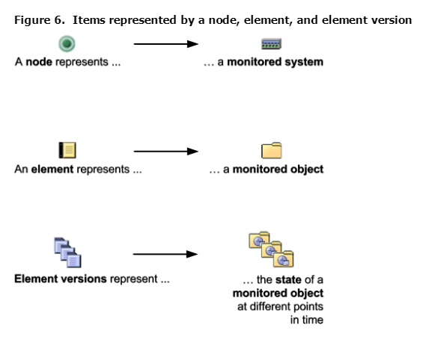

**RULES**: A **rule** identifies one or more monitored objects.

It identifies a component of a node that you want to monitor, known as monitored object. Often a rule specifies a file or a directory in a file system and the attributes of that object (content, permissions, hashes, etc) that you want to monitor. However, rules can also be used to monitor other aspects of a system, such as its availability, or the output that it returns when Tripwire Enterprise runs a specific command.

**ACTIONS:** An **action** initiates a response to change detected by TE or failures generated by policy tests. For example, if TE detects an unauthorized change, an action could send an email notification to appropriate personnel.

**TASKS**: A **task** runs a TE operation on a manual or scheduled basis.

**POLICIES**: A **TE policy** measures the degree to which the configurations of monitored systems are in compliance with a policy, such as an industry or corporate standard.

A **policy test** determines if monitored system comply with a specific requirement of a policy.

**LOG:** A **log message** is a record of network or user activity created by TE.

**REPORTS:** A **report** compiles current data about systems monitored by Tripwire Enterprise. With reports, you can easily review and assess the current state of your network. l

A **dashboard** is a user- defined collection of reports that may be run and viewed at the same time. By adding reports to a dashboard, you can review the latest output for all of the reports in a single window.

**SETTINGS:** Tripwire Enterprise **settings** consist of a variety of TE objects, system parameters, and monitoring preferences.